Deploy MAF-FastAPI App to Azure Container Apps

What this deploys
- One Azure Container Registry (ACR)
- One Azure Container Apps Environment
- One Azure Container App running this API
- Foundry runtime configuration via environment variables
- Required RBAC so FoundryChatClient can call the model
  - 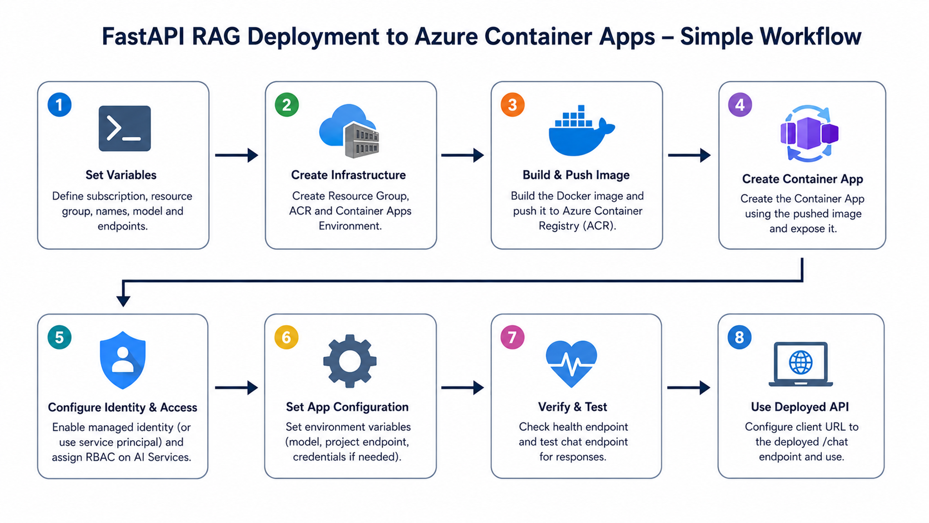

Prerequisites
- Azure CLI installed
- Docker installed (only needed for local container testing)
- Access to an Azure subscription
- A Foundry/AI Services resource with a deployed model
- You are in this folder before running commands
PowerShell:

Set-Location "D:Your_path\Build_real_world_agents\FastAPI app"
az login

1) Set deployment variables
Update only values in quotes.

$SUBSCRIPTION_ID = "<your-subscription-id>"
$RESOURCE_GROUP = "rg-maf-rag"
$LOCATION = "canadacentral"
$ACR_NAME = "mafragacr"
$ACA_ENV = "mafrag-env"
$APP_NAME = "maf-rag-api"
$IMAGE_NAME = "maf-rag-fastapi"
$IMAGE_TAG = "v1"
$IMAGE = "$ACR_NAME.azurecr.io/$IMAGE_NAME:$IMAGE_TAG"
$FOUNDRY_PROJECT_ENDPOINT = "https://obs-test-resource-resource.services.ai.azure.com/api/projects/obs-test-resource"
$FOUNDRY_MODEL = "grok-4.3" #any deployed model
# Scope where RBAC is applied (AI Services account scope)
$FOUNDRY_SCOPE = "/subscriptions/<your-subscription-id>/resourceGroups/your_resource_group/providers/Microsoft.CognitiveServices/accounts/project_name"
az account set --subscription $SUBSCRIPTION_ID

2) Create infrastructure (one time)

az group create --name $RESOURCE_GROUP --location $LOCATION
az acr create --name $ACR_NAME --resource-group $RESOURCE_GROUP --sku Basic
az containerapp env create --name $ACA_ENV --resource-group $RESOURCE_GROUP --location $LOCATION

3) Build and push image with ACR build
Run from the project folder.

az acr build --registry $ACR_NAME --image "$IMAGE_NAME:$IMAGE_TAG" .

4) Create the Container App

az containerapp create `
--name $APP_NAME `
--resource-group $RESOURCE_GROUP `
--environment $ACA_ENV `
--image $IMAGE `
--target-port 8000 `
--ingress external `
--registry-server "$ACR_NAME.azurecr.io"

5) Configure app settings for Foundry

Option A (recommended): Managed Identity

- Enable system-assigned identity:

az containerapp identity assign --name $APP_NAME --resource-group $RESOURCE_GROUP --system-assigned

- Get principal id:

$PRINCIPAL_ID = az containerapp show --name $APP_NAME --resource-group $RESOURCE_GROUP --query identity.principalId -o tsv
$PRINCIPAL_ID

- Grant role(s) at the AI Services scope:

az role assignment create --assignee-object-id $PRINCIPAL_ID --assignee-principal-type ServicePrincipal --role "Cognitive Services OpenAI User" --scope $FOUNDRY_SCOPE

If you still see 403 after propagation, add one fallback role:

az role assignment create --assignee-object-id $PRINCIPAL_ID --assignee-principal-type ServicePrincipal --role "Azure AI Developer" --scope $FOUNDRY_SCOPE

- Set non-secret env vars only:

az containerapp update `
--name $APP_NAME `
--resource-group $RESOURCE_GROUP `
--set-env-vars `
FOUNDRY_MODEL="$FOUNDRY_MODEL" `
FOUNDRY_PROJECT_ENDPOINT="$FOUNDRY_PROJECT_ENDPOINT"

Option B: Service Principal in env vars
Use this only if managed identity is not possible.

$AZURE_TENANT_ID = "<tenant-id>"
$AZURE_CLIENT_ID = "<client-id>"
$AZURE_CLIENT_SECRET = "<client-secret>"

az containerapp update `
--name $APP_NAME `
--resource-group $RESOURCE_GROUP `
--set-env-vars `
FOUNDRY_MODEL="$FOUNDRY_MODEL" `
FOUNDRY_PROJECT_ENDPOINT="$FOUNDRY_PROJECT_ENDPOINT" `
AZURE_TENANT_ID="$AZURE_TENANT_ID" `
AZURE_CLIENT_ID="$AZURE_CLIENT_ID" `
AZURE_CLIENT_SECRET="$AZURE_CLIENT_SECRET"
Then assign RBAC to that service principal object id on the same scope.

6) Get URL and verify health

$FQDN = az containerapp show --name $APP_NAME --resource-group $RESOURCE_GROUP --query properties.configuration.ingress.fqdn -o tsv
$BASE_URL = "https://$FQDN"
$BASE_URL
Invoke-RestMethod "$BASE_URL/health"
Expected response:

{
"status": "ok"
}

7) Verify chat endpoint

$body = @{ question = 'How many annual leave days are employees entitled to?' } | ConvertTo-Json
Invoke-RestMethod -Method Post -Uri "$BASE_URL/chat-json" -ContentType 'application/json' -Body $body | ConvertTo-Json -Depth 5
If successful, you should receive an answer field.

8) Configure local client to call deployed API
In .env:

AGUI_SERVER_URL="https://<your-fqdn>/chat"
Then run:

python client.py

9) 403 troubleshooting playbook (important)
If logs show PermissionDeniedError 403 from FoundryChatClient:
- Confirm the app identity actually used by DefaultAzureCredential.
  - If AZURE_CLIENT_ID and AZURE_CLIENT_SECRET are set, service principal is used first.
  - If not set, managed identity is used inside Container Apps.
- Confirm role assignment scope is correct.
- Use the AI Services account scope that backs your Foundry project.
- Confirm model deployment exists and name matches exactly.

az cognitiveservices account deployment list --name obs-test-resource-resource --resource-group Obs-resource-group -o table
- Wait 5 to 15 minutes for RBAC propagation, then retry.
- If model-specific access is blocked, test with another deployed model to isolate entitlement issues.

10) Useful operations
View app logs:

az containerapp logs show --name $APP_NAME --resource-group $RESOURCE_GROUP --tail 100
Update to a new image tag:

$IMAGE_TAG = "v2"
$IMAGE = "$ACR_NAME.azurecr.io/$IMAGE_NAME:$IMAGE_TAG"
az acr build --registry $ACR_NAME --image "$IMAGE_NAME:$IMAGE_TAG" .
az containerapp update --name $APP_NAME --resource-group $RESOURCE_GROUP --image $IMAGE

Final checklist
- Container app is externally reachable
- Health endpoint returns status ok
- Chat-json endpoint returns answer
- Foundry model and project endpoint are set
- Correct identity has RBAC on AI Services scope
- AGUI_SERVER_URL points to /chat on deployed app

